**Requirement:**

All projects must demonstrate that they have taken steps to ensure the project anticipates, prevents, and does no harm by design.

**Approach taken for development of Aajeevika:**

In terms of UI/.UX design, the platform has been designed in a user-friendly manner enabling ease of use, easy navigation, smart search which ensures that user interactions on the platform do not interfere with the user’s work, result in frustration for them, or prevent them from completing their work. In order to achieve this, user Survey was done by UNDP using Google form survey tool while designing the application. The seller and buyer survey analysis is available (https://github.com/UNDPIndia/Aajeevika)

Seller Survey form-

https://docs.google.com/forms/d/e/1FAIpQLSeWMo9UkbU9UO1i44Rl2g5DYAFxiU64mGq5CLJ3rEW3mhW3gg/viewform?pli=1

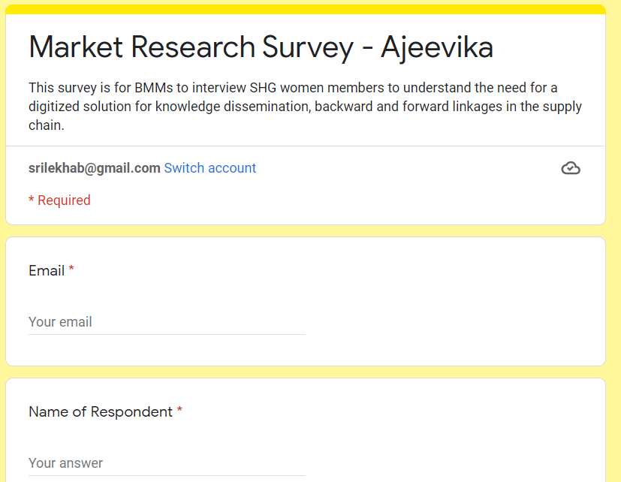

In addition to this, the application does not extract any other data other than what user has given consent for. The application also secures users’ personal information by masking them like contact details by masking them.